 |  | 94 Chiswick High Road , London W4 1SH  Telephone 020 8630 0615  Fax 020 8747 8323  learning@rambert.org.uk

ROOSTER

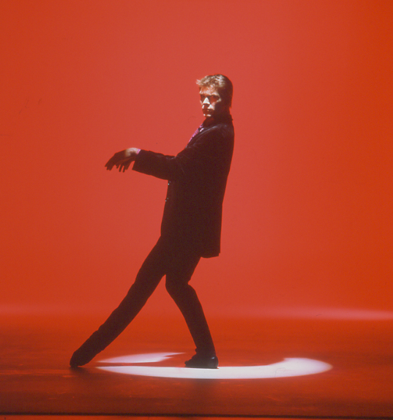
Photos © Anthony Crickmay

Choreography by Christopher Bruce
Music : Songs recorded by The Rolling Stones
Little Red Rooster / Lady Jane / Not Fade Away / As Tears Go By / Paint It Black / Ruby Tuesday / Play With Fire / Sympathy For The Devil

Costume designs by Marian Bruce
Lighting designs by Tina MacHugh

Study Notes written by Jane Pritchard

Rooster was created for Ballet du Grand Theatre de Geneve on 10 October 1991.

It received its British premiere performed by London Contemporary Dance Theatre at the Grand Theatre, Leeds on 28 October 1992.
It was first performed by Rambert Dance Company at the Theatre Royal, Newcastle-upon-Tyne on 8 December 1994 and was last performed on 29 July 2001 in St Sauvier, Canada.

Rooster is performed by 10 dancers: 5 male and 5 female.

The running time is 27 minutes.

Quotations on Rooster

“It’s a celebration of the music, and therefore it reflects the qualities of the songs including, I have to say, the rather dreadful attitude towards women that it was natural for young men to have in my teenage years. That’s why I made the comparison between the strutting cockerel with his fine feathers and the man dressed up to go out – you know the ‘blue suede shoes’ kind of image. Things have changed for some of us – not enough, perhaps – over the past 20 to 30 years, but it reflects the time. I’m not condoning the attitude, just accepting that it was an attitude of the time. And the women for their part are rather long-suffering, but see through it all with a kind of philosophical humour, so there’s a kind of sexual war going on.”
Christopher Bruce in ‘There’s always an idea’ in Dance and Dancers New Year 1993 p18

“A joyous, witty piece requiring dancers with ‘rubber legs and elastic bodies’ to represent the familiar cocky strutting of the early Mick Jagger.”
Sally Whyte in ‘News’ in Dance and Dancers April 1992 p32

“ What Fokine did for the swan and Ashton for white doves, Bruce does for the barnyard rooster, but not in terms of the classical vocabulary so much as being breathtakingly innovative in jazz/disco/contemporary techniques. His 10 dancers strut, tantalise and switch moods as the songs change, but the dance dominates throughout.”
Nicholas Dromgoole in the Sunday Telegraph 29 November 1992

“Bruce’s dances are shown to be anthropomorphic, with sexual suggestiveness cast in the guise of animal behaviour, and making mockery of courtship rituals. There is a kind of flung looseness to the dancing and there is an overriding sense of mating potential being tested.”
Ann Nugent in The Stage 3 December 1992

The Design

Rooster is set on an undecorated stage in which areas are picked in light. Initially the centre of the stage is illuminated and it is into this pool of light that the first dancer walks performing the ‘Rooster strut’. Sometimes the light fills the stage and at other times just picks out an individual performer (or detail such as the hand fading away at the end of the third song). ‘Sympathy for The Devil’ has the most complex and obviously changing light plot. Bruce rarely has elaborate settings for his works, aware that dancers need plenty of space in which to perform.

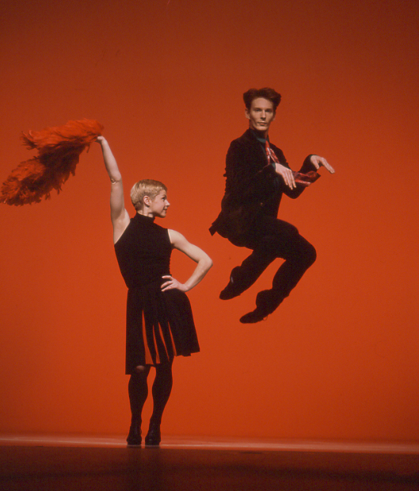
Play with Fire

For the most part the costumes reflect rather than literally reproduce 1960s dress, though the men’s velvet jackets, colourful shirts and co-ordinated ties – all suggesting Jagger’s ‘dandy’ phase – were initially original 1960s garments bought from second-hand shops. The men’s trousers were specially made in strong stretch fabric to give the impression of jeans. Their jackets are maroon, brown, black, green and blue although all four men in ‘Ruby Tuesday’ wear black jackets for that number. Their appearance is varied further when they discard their jackets for ‘Paint It Black’ and ‘Sympathy For The Devil’. The costumes are completed by black jazz shoes.

While there is individuality and variation in the colourful costumes for the men, the women’s are identical. They wear simple, chic dresses, with a black and red colour-scheme throughout. Initially they wear sleeveless black dresses, the skirts of which fall to just above the knee and have box-pleats with red inserts. For ‘Paint It Black’ and ‘Play With Fire’ the women are in sleeveless black mini-shifts evoking Mary Quant’s 60s fashions. For ‘Paint It Black’ the trio’s costumes are completed by red neck-scarves, and for ‘Play With Fire’ the woman also has a red feather boa which is used as much as a prop as a part of the costume. (For some productions the woman in this number wears the ‘dress’ with red pleats rather than the mini-shift, as in the photo on this page) To give ‘Ruby Tuesday’ a hippie look the solo woman wears a long, full skirted red dress with long sleeves although originally in Geneva she wore a long, straight, black dress with thigh-high split. All the women wear sheer black tights and black jazz shoes.

The Dance

The dance is constructed of eight distinct numbers, each performed to a separate song. As with some of Christopher Bruce’s other works these could easily stand alone, but as a sequence they build up the atmosphere and feel of the ‘swinging’ 1960s and contemporary attitudes. The men perform the most energetic choreography, deliberately showing off, but several sections, notably ‘Not Fade Away’, ‘Paint It Black’, ‘Play with Fire’ and the revised version of ‘As Tears Go By’ end with the men being put down by the women. Although each song provides the focus for a distinctive theme or mood they are sometimes linked – the end of one dance leads seamlessly into the next.

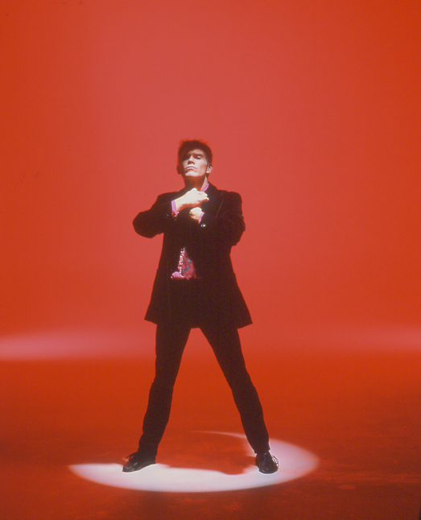

There are a number of movement motifs that recur throughout Rooster including the ballet’s most idiosyncratic step that may be called the ‘Rooster strut’ (see front cover), a stylised walk for the men in which the toes of one foot slide along the floor, the head and neck jut forward, and the rest of the dancer’s body is pulled towards the outstretched extremities. The walk self-evidently mimics the way in which cockerels move. The male dancers also repeatedly perform grooming gestures, slicking down their hair; straightening their cuffs and sleeves; and, most frequently, adjusting their ties (as seen in the photograph on this page). At times they do so while performing the ‘Rooster strut’. There are also several characteristic jumps for the male dancers one of which suggests a chicken trying to fly with his stubby wings. The dancer holds onto the bottom of his jacket lapels so that his arms are bent into the triangular shape of a chicken’s compact wing. He lifts his elbows as he jumps so that they appear to flap as he makes fluttering or ‘bicycling’ gestures with his feet.

Throughout the work everyday gestures, such as the handshake in ‘Sympathy For The Devil’, develop into interesting movements. There is repeated use of the floor on which dancers of both sexes roll and turn. Also repeated in several sections are the extravagant courtly gestures suggestive of the steps of a minuet with its bows and flourishes (see photograph on page 5).

Little Red Rooster Blues number
By Willie Dixon

6 dancers : 5 male, 1 female (the full company comes on stage at the end) Running time 2’55”

The dance opens with the five men stationary on stage. The man downstage right comes to life and moves into the spotlight with the start of the music. His initial dance phrase is the ‘Rooster strut’. Turning to face the audience he appears to sleek down his hair and adjust his tie. On the first appearance of the words ‘dogs begin to bark’ the dancer introduces the wing flapping chicken jump; then on the repeat of these words he acts like a dog, putting his hands up as though they were paws, a dog begging, eager to please, and then he rolls over onto his back, limbs in the air. He leaves stage right as a woman enters upstage and approaches the two men at the back who one by one reject her. At the end of the section the full company comes onto the stage, walking in very deliberate paths either parallel to or at right angles to the front of the stage so that the work ends with eight dancers lined up at the back with one couple downstage in the centre.

Lady Jane

By Mick Jagger and Keith Richards

Full company – 10 dancers. Running time 3’5”.

This gives the initial illusion of a courtly dance with attention focused on the central couple. Although the full company is on stage, for much of the time the other four couples shuffle in a more contemporary social dance at the back or side of the stage from which some of them emerge briefly. Only at the end of the dance, when they come together in a circle, do they all fully participate in the dance rather than provide an animated background.

The central man and his partner ‘Lady Jane’ perform the minuet-style steps and bow to one another. As the words of the song

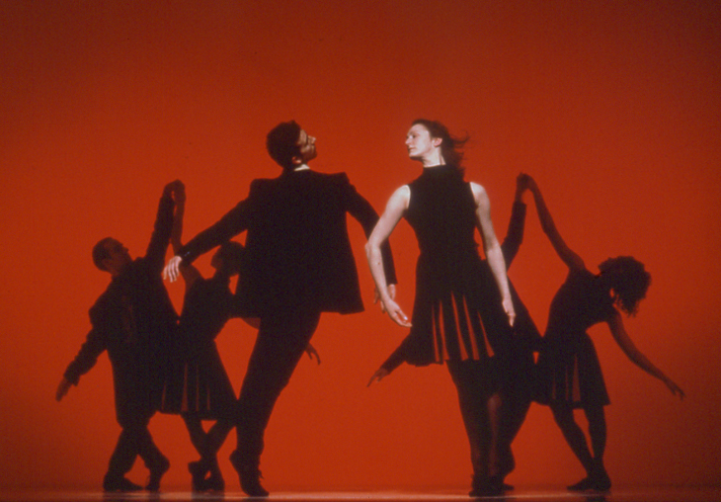
proclaim the man to be ‘Jane’s’ servant he provides his knee for her to sit on. Her gestures and way of moving with her arms crossed over her body suggest a modest demeanour. As the song progresses to the second verse a more pushy woman ‘Lady Ann’ takes ‘Jane’s’ place and the couples on the fringe realign, but ‘Jane’ returns for the musical interlude. This ends with the couple reclining facing one another. ‘Jane’ is lifted away and ‘Sweet Marie’ takes her place; but at the end of the final verse, as the dancers link hands in a circle, the man again turns to ‘Jane’, whom he lifts into the centre of the group, her hands raised ready to give the introductory claps for the next number.
Lady Jane

Not Fade Away
By Petty and Hardin (1957)
Originally recorded by Buddy Holly and the Crickets, cover version by the Stones in Bo Diddley style.

2 dancers : 1 male and 1 female. Running time 1’48”.

The group disperse, walking backwards off the stage leaving only one couple. Their duet is based on social dancing but the girl expends only a minimum of energy while the man shows off. At the end he departs with three other men while the girl, upstage left, traces a vertical wave of air with her hand as she crouches down and in the diminishing light fades away.

As Tears Go By
By Mick Jagger, Keith Richards and Andrew Oldham

8 dancers : 4 male and 4 female. Running time 2’45”.

One man (who appears to be primarily an observer, watching and walking naturally through the action) and one woman stand outside a group of friends who clearly want nothing to do with them. The other three men and three women make two gender cliques and occasionally form cross group partnerships. The women seem intrigued by the outsider man but neither clique is interested in the isolated woman. There is a telling moment when the three women link outstretched arms as if going into a folk dance, typical of Bruce’s choreography in the 1980s. The outsider woman joins the end of the line, but the others stare at her and she drops away giving a visual image of an individual rejected by the community. There is a child-like quality to the isolated woman’s skips, turns and little runs, and selfishness to her behaviour. The outsider man periodically goes to her support but gets his face slapped for his pains. At the end of the song she is left crouching centre-stage and attracts his attention by waving her arm. He pulls her up and carries her off over his shoulder.

PAINT IT BLACK

By Mick Jagger and Keith Richards

4 dancers : 1 male and 3 female. Running time 3’10”.

This is an energetic solo for a man, supported by a female backing group moving in unison with a provocative dance routine that resembles those for the former television dance group Pan’s People. The women’s dance routine is repeated with the repetition of the words. The tall, long haired women of Geneva Ballet look like Amazons in this section, but to achieve the same effect with later casts Bruce made the dancers more aggressive - instead of just waving their red scarves triumphantly as they exit, they now also use them to whip their male victim.

Ruby Tuesday

By Mick Jagger and Keith Richards

5 dancers : initially a solo for a woman later joined by 4 men. Running time 3’10”.

Just as ‘Paint It Black’ is primarily a solo for a man, this is a solo for a woman although towards the end she is joined on stage by four men who similarly perform simple dance routines in unison or pairs giving the impression of the conventional movements of a standard vocal backing group. (A similar dance for a soloist and backing group in the ‘Whispering Grass’ section of Richard Alston’s 1983 work Java has been described by its choreographer as a ‘microphone dance’.) The choreography for the woman is very typical of Bruce’s style with a low centre of gravity and flowing movement. There is an emphasis on yearning arabesques and off-balance, turning movements which propel the dance along. During the dance the soloist fiddles with her hair, picks something from the ground faintly echoing gestures from the mad scene in Giselle and twists her arms and hands with the suggestion of underlying tension. Towards the end of the dance the soloist throws herself into the men’s arms and they manipulate her in more twists and turns developing the material she previously performed on her own.

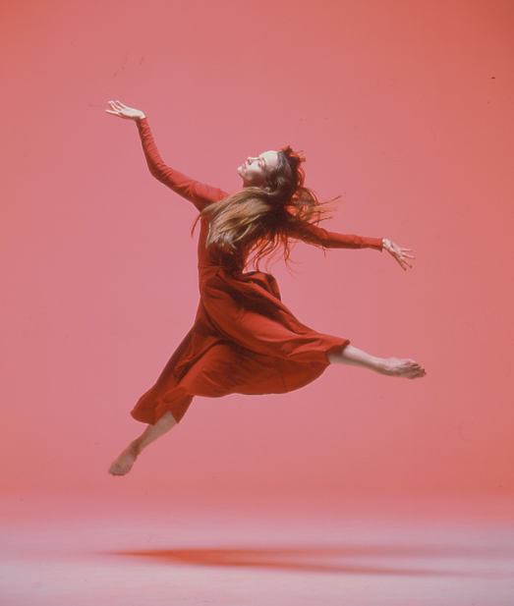
Ruby Tuesday

Play With Fire

By Mick Jagger and Keith Richards

2 dancers : 1 male and 1 female. Running time 2’ 10”.

In some respects, like the ‘Not Fade Away’ duet, this section draws on social dance, giving the male dancer the more flamboyant steps. The introduction of the red feather boa as a prop and a more varied use of popular dance forms provides a contrast to the earlier duet.

Sympathy For The Devil

By Mick Jagger and Keith Richards

Full company 10 dancers. Running time 7’ 20”.

This is a fast and energetic dance with repeated entrances and exits for all the company although the focus is on the men who begin the number. It features elaborate bows of introduction and the placing of forefingers immediately above the head (to represent the horns of the Devil). Dancers enter and exit picking up movement material from one another, performing in unison both paralleling and reflecting one another’s gestures. Just as the words ‘Pleased to meet you’ are illustrated by courteous bows so, for example, the words ‘made damn sure that Pilate washes his hands and sealed His fate’ are depicted by a solo dancer ‘washing’ his hands round one another.

The final section of this dance is a quick reprise of all eight preceding numbers. Inevitably it opens with the Rooster strut followed by a girl lifted by the two men at the end of ‘Little Red Rooster’. The dancers then perform in quick succession the minuet-style movement from ‘Lady Jane’; duet material from ‘Not Fade Away’; the face-slap from ‘As Tears Go By’; the male soloist’s encounter with the amazons from ‘Paint It Black’; the woman’s leap into the four men’s arms from ‘Ruby Tuesday’; and duet material from ‘Play With Fire’. Finally, after a reprise of the elaborate introductions by the devil, the soloist of the first piece goes into the ‘Rooster strut’ and, as he adjusts his tie yet again, the lights go out.

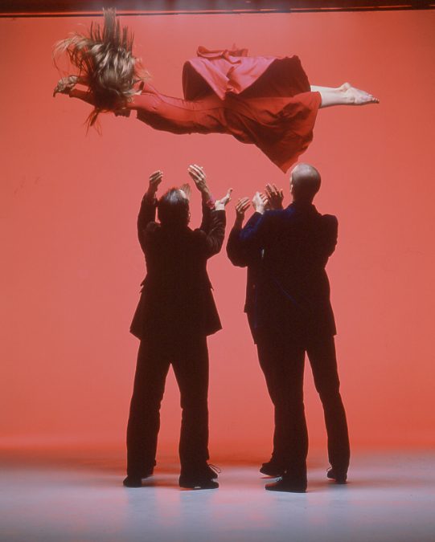
Ruby Tuesday

Rooster in the context of Bruce’s Choreography.

Rooster continued a trend that developed in Christopher Bruce’s work in the 1980s of choreographing to cycles of songs, usually compilations he had chosen himself. This began in 1981 with the Holst songs for Dancing Day created for students of the Rambert Academy, and was followed by the highly acclaimed Ghost Dances for Ballet Rambert to Andean folk music. This latter showed a group of people in limbo between life and death re-enacting their fate on earth. The same year Bruce created Holiday Sketches to Billie Holiday songs for students of London Contemporary Dance School which he later reworked for the repertories of Janet Smith and Dancers, Australian Dance Theatre and Nederlands Dans Theater. In 1984 Bruce followed the success of Ghost Dances with Sergeant Early’s Dream which through Irish and American folk songs looked at the experience of displaced people (in this instance particularly Irish emigrants to the New World in the nineteenth century). At the same time Bruce was creating his dance-work evoking the life and times of John Lennon The Dream Is Over. (This is erroneously referred to as Working Class Hero in several of the reviews of Rooster – the critics clearly recalled the most effective number in the work.) Originally commissioned for a television documentary on Lennon and performed by the Cullberg Ballet the dances provide visual comments on his life. In the programme, shown on The South Bank Show on 30 November 1985, Bruce was also interviewed about the impact Lennon had made on him personally in the 1960s and 1970s. Sixteen months later The Dream Is Over was adapted for London Festival Ballet to perform onstage.

Given the inclusion of songs popularised by Joan Baez in Sergeant Early’s Dream and the use of Lennon’s music for The Dream Is Over, Rooster was the third work that Bruce has choreographed using music he grew up with. As he put it in an interview in Dance and Dancers (New Year 1993) ‘I did the piece because I just loved the music – eight songs by the Rolling Stones, mostly numbers that I’ve lived with for twenty years’. Although the use of selections of popular song has been a feature of contemporary dance in the United
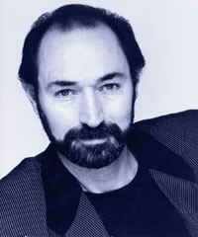

States of America – Twyla Tharp for example
has repeatedly turned to this source using a wide selection of music from the Beach Boys for Deuce Coupe (1973) to Frank Sinatra for Nine Sinatra Songs (1982) – British choreographers have used them less frequently, at least until the 1980s.

Within these brief dance sketches performed to songs Bruce frequently draws choreographic motifs from the lyrics. This has been a feature of his work since his earliest creations and not restricted to his dance-works to popular songs. When reviewing Living Space, a dance set to poems by Robert Cockburn, Noel Goodwin in Dance and Dancers (January 1970 p35) observed Bruce ‘occasionally taking a literal cue from the words’.

Basing a ballet around a succession of numbers inevitably makes it episodic; but each song is an individual miniature sketch which allows for considerable variety of mood and style within the complete ballet. Themes found in Rooster that are recognisable from Bruce’s other works include, for example, references to children’s behaviour. This featured more strongly in his work when his own children were younger, as he said in an interview in The Times (6 March 1981), ‘You will see things about children in many of my works’. Social and folk dance are regularly drawn on and the duets in Rooster echo movement material from, for example, the second movement of Bruce’s Symphony in Three Movements (1989). The stylised movement of ‘Lady Jane’ can be linked to the formal dances of the opening and close of Bruce’s work for Rambert, Ceremonies (1986) in part inspired by the discoveries of the Elizabethan alchemist and Court astrologer Dr John Dee. Later works by Bruce in the structural style of Rooster, included Moonshine (1996) and Grinning in your Face (2001).
The Stones in the 60s

Rooster is performed to music recorded by the Rolling Stones between 1964 and 1969. The eight pieces selected are well known. Two are rhythm and blues standards, the other six are by Mick Jagger and Keith Richards. It was not until the mid-sixties that the Stones concentrated on recording their own, original material. The Rolling Stones date their founding from July 12 1962 when a six-man group including Jagger, Richards and Brian Jones (then calling himself Elmo Lewis) performed at the Marquee Club in London’s West End. Although Jagger and Richards had known one another at Wentworth Junior County Primary School, their paths had diverged until a chance reunion on a train led them to reveal a shared passion for rhythm and blues. Indeed all three men were highly enthusiastic devotees of this tradition of black American music and it was by promoting it as popular form that they established their own status among the principal architects of British rock music.

The group went through a number of permutations – Bill Wyman joined in December 1962 and Charlie Watts officially from January 1963 – and they became increasingly popular playing clubs and venues in and around London, including the Crawdaddy Club at Richmond. Their repertory at this time was largely inspired by Chuck Berry, Bo Didley and Jimmy Reed. In May 1963 the Stones signed a management contract with Andrew Oldham; Oldham finally fixed the line-up of five, added a ‘g’ to their earlier name of the Rollin’ Stones, and arranged a three-year recording contract with impact who in turn signed a release agreement with Decca. In June 1963 the group released their first single, Come On and I Wanna Be Loved.

In spite of Oldham’s attempts to mould the group so that they performed in Mod velvet collared jackets and matching ties, he could not disguise their sullen performing style, a rebellious and uncouth image that affronted conservative opinion and contrasted with the more wholesome package offered by the Beatles. The Stones aroused further controversy by their risqué, aggressive, and sometimes misogynistic lyrics.

The 1960s were an era of both aggressiveness and peace and the Stones were caught up with both, as well as the drug-taking, hippie elements of the end of the decade. They certainly divided opinion and constantly aroused debate. On the one hand eleven Coventry school-boys were suspended in 1964 for having ‘Mick Jagger
haircuts’ and in 1965 a Wrexham teacher attacked parents for allowing their sons to wear ‘Rolling Stones’ corduroy trousers. On the other the solicitor representing Jagger in a case concerning a driving offence in 1964 pleaded against prejudice in respect of his clients long hair and William Rees-Mogg, in a famous Times editorial (on 1 July 1967 headlined ‘Who breaks a butterfly on a wheel?’), protested against the prison sentences handed to Jagger and Richards for the possessions of drugs.

The 1960s for the Stones ended with two extraordinary and memorable free concerts which in themselves highlighted the contrasts of the era. On July 5 1969, just two days after the death of Brian Jones, they presented an open-air performance in Hyde Park, London. It was filmed for television as The Stones in the Park and, in tribute to their missing guitarist, Jagger recited Shelley’s resonant lament Adonais and 3,000 butterflies were released. Just five months later, on 6 December 1969, the Stones gave what was intended to be a similar event at the Altamont Speedway, Livermore, California. The atmosphere however, was charged with a totally different air of tension and the concert is remembered as the occasion when 18-year old Meredith Hunter was stabbed to death by Hell’s Angels.

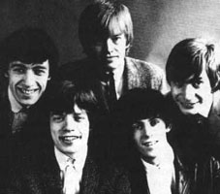

Performance History of Rooster

Ballet du Grand Théâtre de Genéve

First performed: 10 October 1991 at the Grand Théâtre de Genéve, Switzerland.
First Cast: Gabriele Manferdini, Lucas Crandall, Guilherme Botelho, Christopher Chang, Rafi Sadi, Lea Havas, Marie-Josée Joore, Tamar Shelef, Simone Ferro, Didy Veldman.
First programmed with: Forgotten Land (Jiri Kylian) and Le Sacre du Printemps (Kim Brandstrup).

7 performances: 10-17 October 1991
7 performances: 10-17 October 1994 -programmed with Spring and Fall (John Neumeier) and The Four Temperaments (Oscar Araiz)
(1994 revival: Assistant to Bruce: Iracity Cardoso)

London Contemporary Dance Theatre
First performed: 28 October 1992 at Leeds Grand.
First Cast: Darshan Singh Bhuller, Peter Dunleavy, Tracey Fitzgerald, Kate Coyne, David Hughes, Bernadette Iglich, Leesa Phillips, Kenneth Tharp, Tom Ward, Sheron Wray
First programmed with: Motorcade (Mark Morris) and My Father’s Vertigo (Amanda Miller)

Rambert Dance Company
First performed: 8 December 1994 at the Theatre Royal, Newcastle.
First Cast: Sheron Wray, Marie-Laure Agrapart, Kate Coyne, Didy Veldman, Joanne Fong, Steven Brett, Simon Cooper, Rafael Bonachela, Glenn Wilkinson, Vincent Redmon.
First programmed with: Banter, Banter (Baldwin), Land (Bruce), Petite Mort (Kylian).
Last performance: 29 July 2001 at the Big Top, St Sauveur, Canada programmed with Sounding (Siobhan Davies), Hurricane and Ghost Dances (Bruce).

Dutch National Ballet
Staged by: Sheron Wray and Michele Braban. Repetitor: Judy Maelor-Thomas
First performed: 25 April 1997 at Stadsschouwburg, Amsterdam, Holland.
First programmed with: Collective Symphony (Rudi van Dantzig, Hans van Manen, Toer van Schayk) and Violin Concerto (George Balanchine).

Houston Ballet

Choreographic Assistant: Michele Braban
First performed: 25 May 1995 at the Brown Theater, Wortham Center, Houston. U.S.A.
First Cast: Lauren Anderson, Tiekka Schofield, Dawn Scannell, Joyce Yost, Erika Johnson, Mark Arvin, Christopher Veljovic, Timothy O’Keefe, Dominic Walsh, Sean Kelly.
First programmed with: ‘Haffner’ Symphony (Helgi Tomasson) and Sinfonietta (Jiri Kylian)
Sponsored by: The Cullen Trust for the Peforming Arts and Burlington Resources/Meridan Oil Foundation

Ballett Deutsche Oper am Rhein
Choreographic Assistant: Michele Braban
First performed: 24 June 2000 at theTanzhaus NRW, Düsseldorf, Germany.
First programmed with: Tendanze (Richard Wherlock) and Trilogy – Cry Baby Kreisler, Highly Strung, Girl Band, (Matthew Hart) under the overall programme title New British Dance

Television
Rooster performed by the original cast from the Ballet du Grand Théâtre de Genéve televised by RM Arts/Danmark Radio Director Thomas Grimm with the original cast. First shown on British television on Summer Dance, BBC2 19 August 1995

Two extracts from Rooster – ‘Play with Fire’ danced by Maria Sardon Urtiaga & Vincent Redmon and ‘Ruby Tuesday’ danced by Patricia Hines, Rafael Bonachela, Laurent Cavanna, Chris Powney, Vincent Redmon were performed by on the Royal Variety Show transmitted 20 December 1998.

Rooster was performed by Matthew Hart on The Generation Game, ITV September 1998.

Rambert Dance Company performances of Rooster

Britain

- Newcastle-upon-Tyne

- Brighton, Norwich, Swindon, Ashton-under-Lyne, Edinburgh, Carlisle, Glasgow, High Wycombe, Sheffield, Dartford, Cardiff, Bournemouth, Blackpool

- Northampton, Oxford, Canterbury, Mold, Swansea, Nottingham, Leeds, Birmingham, London (London Coliseum), Aberdeen, Bristol

- Oxford, Edinburgh, Manchester, Woking, Sheffield, Swansea

- Truro, Newcastle, Manchester, Sheffield

- London (Sadler’s Wells)

2001 London (Sadler’s Wells)

Overseas

Australia Perth, 2001
Adelaide, 2001
Melbourne, 2001

Austria Vienna, 1996
St Poulten, 1999

Belgium Brussels, 1996

Canada Toronto, 1996
St Sauveur, 2001

Cyprus Nicosia, 1999
Limassol, 1999

Denmark Oldenberg, 1995
Copenhagen, 1995
Aarhus, 1995

Germany Leverkusen, 1996
Cologne, 1996, 2001
Dusseldorf, 1996
Duisberg, 1996
Neuss, 1996
Ludwigshafen, 1996
Frankfurt, 1996
Friedrichshafen, 1998
Furth, 1998

Hungary Gyori, 1998
Budapest, 1998

Luxembourg 1998

Mexico Monterrey, 1998
Mexico City, 1998

New Zealand Wellington, 2001
Auckland, 2001

Russia St Petersberg, 1997
Nizhny Novgorod, 1997
Moscow, 1997

Singapore 2001

Thailand Bangkok, 1996

Ukraine Kiev, 1999

USA New York, 1996
Berkeley, 1998
Malibu, 1998
Los Angeles, 1998
Costa Mesa, 1998
Palm Desert, 1998

Bibliography

ANON ‘Rambert strong and polished’ in The Dominion (NZ), 15 March 2000.

Rita CLARKE ‘Born-again Rambert bewitches’ in The Australian, 9 March 2001.

Clement CRISP 'A Rooster on top of the pops' in the Financial Times, 25 November 1993.

Nicholas DROMGOOLE 'Barefoot and back on course' in the Sunday Telegraph, 29 November 1992.

Rita FELICIANO ‘San Francisco report a spicy kettle of fish’ in Danceview 15, 2 March 1998, p 44.

Gareth HANCOCK 'Mick Jagger and the Rolling Stones' in the Dancing Times, May 1993, p 848.

Samela HARRIS ‘Rich in manner’ in The Advertiser, 30 March 2001, p 28.

Barbara KARKAIN 'Rooster struts its Stones stuff' in Houston Chronicle, 27 May 1995, p 4D.

Nadine MEISNER 'A marching charging feat' in The Times, 7 November 1992.

Ann NUGENT 'Sadler's Wells LCDT' in The Stage and Television Today, 3 December 1992, p 15.

Jann PARRY ‘This rooster’s not quite the cock of the walk’ in The Observer, 29 November 1992, p 58.

Jann PARRY 'Gimme Shelter' in Dance Magazine, March 1993.

Jann PARRY 'London Contemporary Dance Theatre' in The Dancing Times, January 1994, p 338-339.

John PERCIVAL 'Something to crow about' in The Times, 28 October 1992, p 31.

John PERCIVAL 'Mick, Keith, Charlie, Brian, Bill and Christopher' in The Times, 26 November 1992.

Margaret PUTNAM 'It's no longer only rock 'n' roll' in The Dallas Morning News, 26 May 1995.

June RICHARDS 'Leap of Faith' in the Sunday Express, 29 January 1995.

Anne SACKS 'Not with a whimper but a bang' in The Independent on Sunday, 5 December 1993.

Mitchell J. SHIELDS 'Songs and Dance. Houston Ballet strut for success' in Houston Press, 1-7 June 1995.

Allan ULRICH ‘British, unreserved’ in San Francisco Examiner, 28 February 1998, p B1, B4.

Videos

Rooster performed by Ballet du Grand Theatre de Geneve and Nacho Duato’s Jardi Tancat (DV16)

Resources available to buy

NEW! Christopher Bruce’s Triple Bill (CBDVD)
Features 3 works including Rooster £31.72
Available for the first time from Rambert, 3 seminal works by former Artistic Director Christopher Bruce together on one DVD. The ever popular Rooster, Swansong and Silence is the End of Our Song.

