Mats Ek – Choreographer & Dancer
From Wikipedia, the free encyclopedia
Mats Ek (born 18 April 1945) is a leading Swedish dance and ballet choreographer, dancer and stage director.^{[1]} He was the manager of the Cullberg Ballet from 1985 to 1993.

Life and career

Ek was born in Malmö in 1945, the son of the Royal Dramatic Theatre actor Anders Ek and famous choreographer Birgit Cullberg.
At 17, he followed a summer dance course (modern) taught by Donya Feuer. He pursued theatrical studies at the Marieborg Folks College in Sweden. From 1966 until 1973, he acted as the director for the Marionett Theater as well as the Royal Dramatic Theatre in Stockholm.
In 1972, Ek joined the Cullberg Ballet. In 1975, he formed part of the corps de ballet for the Ballett der Deutschen Oper am Rhein in Düsseldorf. And in 1976, he made his first choreography titled The Officer's Servant for the Cullberg Ballet. In 1978, Ek became, together with Birgit Cullberg, artistic director of the Cullberg Ballet, until 1985 when the responsibility became his entirely. This position he fulfilled until 1993. During the season 1980-1981, he was associated with the Nederlands Dans Theater as dancer as well as choreographer.
In some of Ek's former choreographies, traditions of Kurt Jooss and of his mother, Birgit Cullberg may be apparent. He uses classical as well as modern dance techniques. Social engagement of psychological dilemmas combined with subtle humor, form the basis of his choreographies. For Ek, movement is a means of individual expression. Aesthetic value is not his first priority.
He has for thirty years been a highly esteemed choreographer throughout the world. He studied dance and theatre and directed theatre at the Marionette Theatre, the Stockholm City Theatre and the Royal Dramatic Theatre. In 1973 Mats Ek joined the Cullberg Ballet as a dancer. Three years later he began choreographing for the company with immediate success. Saint George and the Dragon, Soweto and The House of Bernarda belong to his earliest ballets. From 1981 until 1993 Mats Ek was the artistic director of the Cullberg Ballet, succeeding his mother Birgit Cullberg. Mats Ek's extensive production of ballets includes more than twenty works for the Cullberg Ballet, among them the sensational reworks of the great classics like Giselle (1982), Swan Lake (1987) and Carmen (1992). After leaving the Cullberg Ballet, Mats Ek became guest choreographer with major international dance companies. He created Sleeping Beauty for the Hamburg Ballet (1996), A Sort Of for the Nederlands Dans Theater (1997), and Apartment for the Paris Opera (2000). Several of Mats Ek's ballets have been adapted for television, two of them received Emmy awards.
Mats Ek is also acclaimed for his choreographic theater works, Don Giovanni (1999) and Andromaque (2001) at the Royal Dramatic Theatre being two of them. With his latest choreography FLUKE, premiered in November 2002 at Dansens Hus in Stockholm, Mats Ek has once again created a work for the Cullberg Ballet, this time in cooperation with the Pork Quartet.
In 2006, he won the Prix Benois de la Danse.

Mats Ek
Profile: Mats Ek is the son of Anders Ek, one of Sweden’s most celebrated actors, and Birgit Cullberg, the choreographer and artistic director for the Cullberg Ballet Company. He was born in Malmö in 1945, and began a short period of dance studies in 1962 with Donya Feuer in Stockholm; in addition, he later took theatre studies in Norrköping.
The Early Years: From 1966 to 1973 Ek worked as stage director and assistant at the Royal Dramatic Theatre of Sweden and the Marionette Theatre in Stockholm. In 1972 he re-established his contact with dance, and in 1973 began dancing with the Cullberg Ballet.
Choreography: In 1974–5, Ek was a member of the Deutsche Oper am Rhein, Düsseldorf, then made his choreographic debut in 1976 with The Officer’s Servant, for the Cullberg Ballet, the first of many of his works formed on them.Through such early pieces as Soweto (1977) and The House of Bernarda (1978) he began to gain an international profile, one that was strengthened in the many subsequent works for the Cullberg Ballet, most immediately those of The Four Seasons (1978) and Antigone (1979).
In 1980–81 he became a member of Nederlands Dans Theater, and his associations with the company have continued in works later created for them: Over There (1990), Journey (1991) and A Sort Of (1997).
From 1980 to 1984, Ek shared the artistic directorship of the Cullberg Ballet with Birgit Cullberg. Then, in 1985, he was appointed sole artistic director, a post he held until 1993. Giselle (1982) and The Rite of Spring (1984), both for the Cullberg Ballet, had already shown his interest in reinterpreting the classical repertory, one fostered during his time in the company of the Deutsche Oper am Rhein, with whom he performed such works as The Sleeping Beauty, Giselle and Romeo and Juliet. This important strand of his choreographic exploration has continued with his own particular slants on the familiar presented in Swan Lake (1987), Carmen (1992) and The Sleeping Beauty (for the Hamburg Ballet, 1996).
After leaving the Cullberg Ballet in 1993 he continued to be prolific in his choreography, producing such works as She was Black (1995), and the TV ballet Smoke (1995), which he reworked as Solo for Two in the following year. He has also become a guest choreographer for the leading companies of the world, working with, among many others, the Royal Swedish Opera, the Norwegian Opera, Stuttgart Ballet, American Ballet Theatre, La Scala,Milan, Metropolitan Opera, New York, and Paris Opera Ballet. In 2008 he created Place, a pas de deux for Ana Laguna and Mikhail Baryshnikov, and Black Radish for the Royal Swedish Ballet.
Ek’s style has become distinctive for its imaginative interpretations of storylines, in combination with a lyrical approach which conveys through movement the underlying emotions and feelings rather than just the narrative detail.
Theatre: Ek has retained his interest in other forms of theatre, staging productions of plays including Marlowe’s The Jew of Malta (Orion Theatre, Stockholm, 1998), and Molière’s Don Juan (1999), Racine’s Andromaque (2002) and Strindberg’s A Dream Play (2006) for the Royal Dramatic Theatre, Stockholm. In 2007 he staged Gluck’s Orphée for the Royal Swedish Opera.
Mats Ek: Expression & Fluidity
http://www.theballetbag.com/2012/07/13/mats-ek-biography/
When one says Mats Ek, one usually gets two opposite reactions from the dance world: people will either show their enthusiasm and undying admiration, or they will stick their tongues out. His choreography, like Marmite, is one of those topics that leave little room for middle ground. Plus Ek is one of the few choreographers whose works can engage ballet fans, contemporary dance fans and dancers alike.
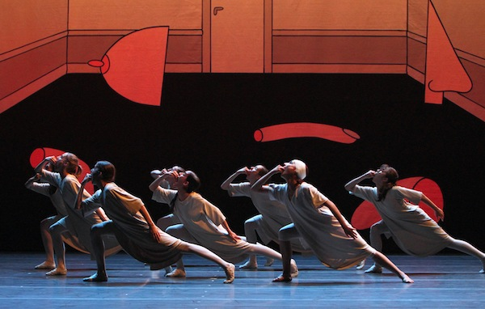
Special guest blogger & contemporary dancer Lu Piquero looks at what the controversial Ek is made of.

Artists of the Bayerisches Staatsballett in Mats Ek's Giselle - Photo: © Wilfried Hösl / Bayerisches Staatsballett
Mats Ek in a Nutshell
Ek was born in Mälmo (Sweden) on the 18th of April 1945 to Birgit Cullberg, dancer, choreographer and founder of Cullberg Ballet, and Anders Ek (one of Ingmar Bergman’s favourite actors). As a young man, Ek initially trained in dance with Lilian Karina and Donya Feuer, but shifted to drama, which he studied at the Marieborg Folks College. He began his career in the theatre, directing the Marionett Theatre and the Royal Dramatic Theatre (Stockholm) between 1966 and 1973. In-between he decided to go back to dance, joining the Cullberg Ballet in 1972.
Ek’s work spans from ballet, theatre and “dance theatre” to TV and opera and he is a regular staple in the repertory of Northern and Central European companies.
Career highlights:
- Danced with Cullberg Ballet, Düseldorf Ballet and Nederlands Dans Theatre (NDT)
- Choreographed his first work for Cullberg Ballet in 1976
- Became co-director of Cullberg Ballet (alongside his mother) from 1978 to 1985, and sole director from 1985 to 1993.
- Left Cullberg Ballet in 1993 to become a freelance choreographer.
- Has choreographed works for major companies like NDT, Hamburg Ballet, Cullberg Ballet and Paris Opera Ballet.
- Won the Prix Benois de la Danse (2006) and has been awarded several Emmys for TV adaptations of his ballets

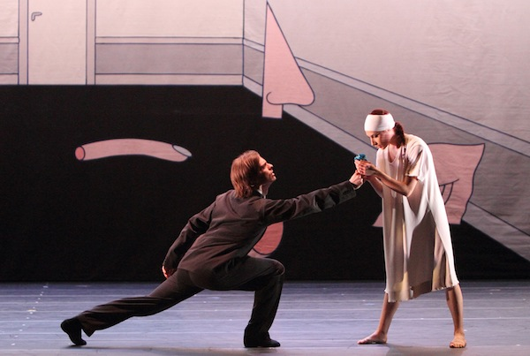

Gözde Özgür as Giselle and Lukás Slavicky as Hilarion - Photo: © Wilfried Hösl / Bayerisches Staatsballett

Ek’s Style
Choreographers that appeal to both the contemporary and classical worlds have one clear thing in common: their work tends to be “technical” or, shall we say, “balletic”. Ek’s movement style is characterised by several signature steps: flexed feet, grand pliés à la seconde, lunges, “wavy” backs, all designed with the same aim, expression. Ek hears his music in a very peculiar way and doesn’t choose the easy path to relate to the score. Musicality is a very important element to his choreography, along with his ability to build up emotions, only to break them dramatically when you least expect it.
This emphasis on expression can hardly be a surprise in Ek, since he descends from an amazingly pure lineage of German dance expressionism (Birgit Cullberg studied with Kurt Jooss who – like Mary Wigman – was a disciple of Rudolf Laban). Another important feature in Ek’s movement style is fluidity. The movement itself seems to never stop, even when it becomes a position. Of this, Ek says:
“The prolongation, the extension of movements is very important to me. For instance, sometimes the foot or the head stays in a position while the body is already going into the next movement.”
He is also fluid when it comes to the treatment of the storyline, aided by changes of perspective, of scene, developing of characters and his ability to keep us wanting to know more all the time.
Ek is also interested in people; characters develop and are brought to the fore. He focuses on relationships between them. From the social issues which featured prominently in his firsts works, to smaller groups and personal, more intimate relationships (family, partners, etc.), all of Ek’s works have one thing in common: they put the focus on the disadvantaged, the ignored and those who are considered “weak” by society.
Bottom-line
Why does Mats Ek generate such strong reactions among members of the audience? The key might be in a different concept of beauty in dance. When choreographing Ek does not look for beauty as we generally understand it. In fact, he sometimes goes against it. Whichever moments of superficial beauty we encounter in his work, they tend to come up more by chance (and the amazing ability of his dancers) than by conception. He creates to express, and sometimes what he is expressing is cruel and ugly. If you are going to watch dance to witness beauty (a perfectly valid reason), Ek might not be for you after all.

Sources and Further Information
- Mats Ek and the Cullberg Ballet by G. Jensen. Dancing Times, volume 87, No. 1043 , 1997.
- Mats Ek: Appartement by Horst Koegler. DVD Booklet. Germany: TDK Marketing Europe GmbH
- Reworking Texts- Inverting Bodies. Mats Ek Radically Reconceives the Classics by V. Midgelow, 1999. Dance Theatre Journal, Volume 15 (Part 2), 4-7.
- Is Mats Ek a Great Choreographer? by Ann Nugent. Dance Theatre Journal, Volume 17 (Part 3), 32-35.
- Choreographers Today: Mats Ek by Giannandrea Poesio. Dancing Times, volume 94 (Issue 1118, October), 22-26. (2003)
Reviews: Dance Review

Visionaries, Innovators and Diviners: Mats Ek
http://www.psychologytomorrowmagazine.com/visionaries-innovators-and-diviners-mats-ek-architect-of-intimacy/
Ek broke with classical tradition because he viewed it as diminishing the possibilities of what dance could do and say, what it could convey. His revisionist ideas drive much of his choreography. Rather than narrating a tale, Ek’s style takes on a lyrical approach, which conveys emotions and feelings through movement. This is what the danced language of the Other looks like and feels like. Perhaps this is what makes Mats Ek a controversial figure: most of his works focus on the disadvantaged, the ignored and those who are considered “weak” by society. Ek works in contrasts and polarities, often setting up opposites so that movement can take place in between. He manages to use the abstractness of dance and literally flesh it out- linking feelings, ideas and memories to a body, and does that body dance!
Part of what makes Ek’s choreography appealing to contemporary and classical dancers alike, is that he retains a precise and definitive technique while releasing the body from the rigidity that technique can impose. Seem like an oxymoron? Take a look at his grand plies ala seconde, or his open jetes, or the flexion of the feet – exact, detailed, explicit – each movement scrupulous and meticulous, a link in a chain of flesh and muscle that expresses the all that is felt and now expressed through the dance.
What is interesting about choreography for Ek, is how it can capture and imitate real life while providing a new context for it through movement. Movement to Ek is limitless in its expressive abilities. It is un-gendered while retaining a rich sensuality that flows effortlessly into the erotic. Ek is interested in relationships between people and the emotions that drive them, and that interest is transformed into the creation of an impression through movement that bypasses the filters of the intellect. It just is. He speaks to the intimacy between partners and family and spans to the wider group and to society, always with a keen eye toward the marginalized and disenfranchised.
Mats Ek is an acquired taste. He is not interested in conveying beauty, although he often does. But in attempting to capture the reality of human nature he often shows us its underbelly: the uglier side, the shadow – and this is depicted and expressed through movement, often angular, shaky and disturbing.
Ek is not here to entertain us and transport us to a magical land (although he does both nonetheless). He asks us to think with him, to enter the dance fully, body, soul and mind, much like one does when one reads a good novel- we are invited and moved to relate fully. Mats Ek provides us with “a way of touching the untouchable”.

