THE PELVIS, KNEE and ANKLE

Pelvis
- Label this pelvis

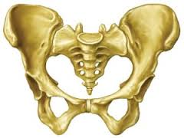

- What are the two main functions of the pelvis (Dancing related)?
- Describe what good hip alignment looks like.
- What is Lumbar Lordosis?
- What is Thoracic Kyphosis?
- What key factors affect the range of movement at the hip joint for each dancer?
KNEE
- Label the knee

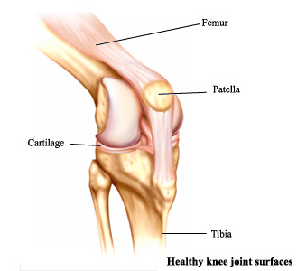

- Describe and draw normal knee alignment
- What type of Joint is the knee joint?
- Knees can be malaligned. What are two forms of Malalignment?

FOOT AND ANKLE
- When standing in neutral position, what is the best position for the feet to be in?
- Describe how weak ankles can lead to malalignment of the knees and hips.

