JOINTS AND MUSCLE ACTIONS
Joints
- What is a joint? Where is it found in the body?

- List two functions of a joint?
-
-

- How many joints are found in the human body?

- List three different types of joints

-
-
-

- There are many types of joint movements

Joint Movement | Meaning
Flexion
Extension
Hyperextension
Dorsi flexion
Plantar flexion
Abduction
Adduction

Muscle actions
- What are the four functions of Muscles?
-
-
-
-

- What is the difference between a voluntary muscle and an involuntary muscle?

- What are the three types of muscles?

- Types of muscles

Types | Examples
Smooth Muscle
Cardiac Muscle
Skeletal Muscle

- What do Antagonist muscles do? Give an example of one

- How does someone maintain body posture and tone?

THE PELVIS, KNEE and ANKLE

Pelvis
- Label this pelvis

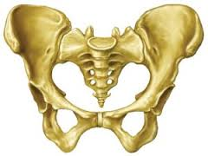

- What are the two main functions of the pelvis (Dancing related)?
- Describe what good hip alignment looks like.
- What is Lumbar Lordosis?
- What is Thoracic Kyphosis?
- What key factors affect the range of movement at the hip joint for each dancer?
KNEE
- Label the knee

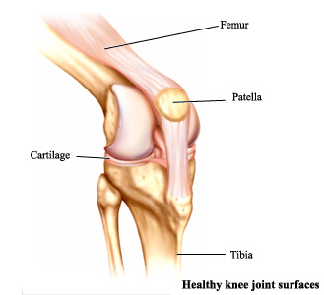

- Describe and draw normal knee alignment
- What type of Joint is the knee joint?
- Knees can be malaligned. What are two forms of Malalignment?

FOOT AND ANKLE
- When standing in neutral position, what is the best position for the feet to be in?
- Describe how weak ankles can lead to malalignment of the knees and hips.

